**VISVESVARAYA TECHNOLOGICAL UNIVERSITY**

“Jnana Sangama”, Belagavi - 590018, Karnataka, India



**A**

**PROJECT REPORT**

**ON**

**“SOCIAL Q&A”**

***Submitted in the partial fulfilment of the requirements***

***for the award of the degree of***

**BACHELOR OF ENGINEERING**

**in**

**COMPUTER SCIENCE AND ENGINEERING**

**For the Academic Year 2021-2022**

**Submitted by:**

**Aditya Rastogi 1JS18CS008**

**Jyothi L 1JS19CS403**

**Amit 1JS18CS015**

**Bharadwaj A 1JS18CS031**

**Under the Guidance of-**

**Mr. Sreenatha M**

**Assistant Professor, Dept. of CSE, JSSATE**



**2021-2022**

**DEPARTMENT OF COMPUTER SCIENCE & ENGINEERING**

**JSS ACADEMY OF TECHNICAL EDUCATION**

**JSS Campus, Dr. Vishnuvardhan Road, Bengaluru-560060**

**JSS MAHAVIDYAPEETHA, MYSURU**

**JSS ACADEMY OF TECHNICAL EDUCATION**

**JSS Campus, Dr. Vishnuvardhan Road, Bengaluru-560060**

**DEPARTMENT OF COMPUTER SCIENCE & ENGINEERING**



**CERTIFICATE**

This is to certify that the project work entitled **“Social Q&A”** is a bonafide work carried out by **Aditya Rastogi (1JS18CS015)**, **Jyothi L (1JS19CS403)**, **Amit (1JS18CS008)**, **Bharadwaj A (1JS18CS031)** in partial fulfilment for the award of degree of **Bachelor of Engineering** in **Computer Science and Engineering** of **Visvesvaraya Technological University, Belagavi** during the year 2021-2022. It is certified that all corrections and suggestions indicated for Internal Assessment have been incorporated in the report. The project has been approved as it satisfies the academic requirements in respect of the project work prescribed for the Bachelor of Engineering degree.

_____________________ ____________________ ____________________

**Mr. Sreenatha M Dr. Naveen.N.C Dr. Bhimasen Soragaon**

Assistant Professor, Professor & Head, Principal,

Dept. of CSE, Dept. of CSE, JSSATE-Bengaluru.

JSSATE, Bengaluru. JSSATE, Bengaluru.

**Name of the Examiners Signature with Date**

**1………………………. ……………………**

**2………………………. ……………………**

**ACKNOWLEDGEMENT**

The satisfaction and euphoria that accompany the successful completion of any task would be incomplete without the mention of the people who made it possible. So, with gratitude, we acknowledge all those whose guidance and encouragement crowned my effort with success.

First and foremost, we would like to thank his **Holiness Jagadguru Sri Shivarathri Deshikendra Mahaswamiji** and **Dr. Bhimasen Soragaon**, Principal, JSSATE, Bangalore for providing an opportunity to carry out the Project Work as a part of our curriculum in the partial fulfillment of the degree course.

We express our sincere gratitude for our beloved Head of the department, **Dr. Naveen.N.C**, for her co-operation and encouragement at all the moments of our approach.

It is our pleasant duty to place on record our deepest sense of gratitude to our respected guide **Mr. Sreenatha M, Assistant Professor,** for the constant encouragement, valuable help and assistance in every possible way.

We are thankful to the Project Coordinators **Mr. Sreenatha M,** Asst. Professor, for their continuous co-operation and support.

We would like to thank all **CSE department teachers** and **non-teaching staff** for providing us with their valuable guidance and for being there at all stages of our work.

**Aditya Rastogi**

**[1JS18CS015]**

**Jyothi L**

**[1JS19CS403]**

**Amit**

**[1JS18CS008]**

**Bharadwaj A**

**[1JS18CS031]**

**ABSTRACT**

Users can post their queries and then choose to answer them within the system. Due to the rapid growth of the user population, it's not likely that a user will accidentally answer a certain query. One of the most important factors that prevents people from producing top quality answers is the lack of time. This is why the design of the web social network, known as ‘SOCIAL Q&A’, is focused on providing a platform that allows users to interact with each other and find the best answer. Its features such as the ability to search for an answer through a user's social network properties are designed to enhance the security of its users. The design of the web social network has been improved to accommodate the needs of its users. Its security and potency have been enhanced to allow it to retrieve and identify answers automatically for perennial queries. The results of this study demonstrate how social networks can be used to enhance the quality of solutions and reduce the waiting period for customers.

The main objective ‘SOCIAL Q&A’ is to boost the performance of Question and Answer systems by proactively directing inquiries to users who are capable as well as willing to answer the queries. ‘SOCIAL Q&A’ also aims to reduce wait time for the user to get answer to their queries.

List of Tables and Figures

1. Table 3.1- Hardware Specification……………………………………………... 19
2. Table 3.2- Software Specification……………………………………………… 20
3. Figure 4.1- Elements of a system………………………………………………. 26
4. Figure 4.2- Flowchart for different categories of information…………………. 30
5. Figure 4.3- Overview of System Design……………………………………….. 31
6. Figure 4.4- Methodology…………………………………................................. 32
7. Figure 4.5- Class Diagram………………………………………....................... 32
8. Figure 4.6- Use Case Diagram…………………………………………………. 33
9. Figure 4.7- User Data Flow Diagram…………………………………………... 33
10. Figure 4.8- User Sequence Diagram………………………………………….... 34
11. Figure 4.9- Admin Sequence Diagram………………………………………..... 34
12. Figure 4.10- Component Diagram…………………………………………….... 35
13. Table 6.1- Test cases of Input-Output…………………………………………... 49
14. Table 6.2- Samples in each class………………………………………………... 51
15. Table 6.3- Accuracy of Social Q&A……………………………………………. 51
16. Table 6.4- Registration test case…………………………………….…………... 53
17. Table 6.5- Login test case……………………………………………………….. 55

Contents

**1.Introduction** 8

1.1 Background 8

1.2 Problem Statement 8

1.3 Existing System 9

1.4 Proposed System 10

1.5 Objectives 11

**2.Literature Survey** 12

2.1 SOS: A Distributed Mobile Q&A System Based on Social Networks 12

2.2 Pythia: A Privacy-enhanced Personalized Contextual Suggestion System for Tourism 13

2.3 Effects of expertise differences in synchronous social Q&A 14

**3.System Requirements Specification** 15

3.2 Requirement Engineering 16

3.3 Types of Requirement 17

3.4 System Requirement 18

**4.System Analysis and Design** 24

4.1 Overview of System Design 30

4.2 Methodology 31

4.3 UML Diagrams 31

**5.Implementation** 36

5.1 Modules 36

5.1.1 User Module: 36

5.1.2 Admin Module: 36

5.2 Algorithm used in Project 36

5.3 Packages Used 39

5.3.1 Scikit-Learn 39

5.3.2 Flask 40

**6.System Testing** 42

Introduction 42

6.1 Types of tests 42

6.1.1 Unit Testing 42

6.2 Functional testing 46

6.3 System testing 47

6.3.1 White Box Testing 49

6.3.2 Black Box Testing 50

6.3.3 Acceptance Testing 50

6.3.4 Performance Testing 50

6.3.5 Experimental Results 50

6.4 Test Cases 52

6.4.1 Test Cases for Register Page 52

6.4.2 Test Cases for Login Page 54

**7.Results and Discussion** 55

**8.Conclusion and Future Scope** 61

8.1 Conclusion 61

8.2 Future Scope 61

**References** 62

**Chapter 1**

# Introduction

## Background

The ability to share information and improve the efficiency of our lives is a vital part of Q&A systems. Users can post their queries and then choose to answer them within the system. Due to the rapid growth of the user population, it's not likely that a user will accidentally answer a certain query. One of the most important factors that prevents people from producing top quality answers is the lack of time. This is why the design of the web social network, known as ‘SOCIAL Q&A’, is focused on providing a platform that allows users to interact with each other and find the best answer. Its features such as the ability to search for an answer through a user's social network properties are designed to enhance the security of its users. The design of the web social network has been improved to accommodate the needs of its users. Its security and potency have been enhanced to allow it to retrieve and identify answers automatically for perennial queries. The results of this study demonstrate how social networks can be used to enhance the quality of solutions and reduce the waiting period for customers.

## Problem Statement

The Internet is a vast storehouse of data, which is constantly developing. Through web search tools, clients can easily find information that they need. For instance, Google and Bing use phrases that clients give them to perform visual tasks. Recently, various mechanical work exercises have been carried out by Microsoft and Facebook, which are in an attempt to improve the efficiency of their web search tools. According to studies, web indexes perform well when it comes to ordering website pages, but they are not appropriate for non-genuine inquiries. For instance, if a client is searching for the best auto shop near me, then I would suggest using Google.

These tools have created various Q&A frameworks, which are designed to address the non-authentic inquiries that clients might encounter. Since their inception, these platforms have been very popular among Internet users. Besides being useful for performing visual tasks, these platforms have also been known to help people share their skills. For instance, in 2005, Yahoo! Answers was able to pull in over 10 million users in February, and it has since gone on to reach 200 million users. These tools also allow users to store all their inquiries and answers in a secure environment. These tools are very useful for sharing information, but they are also known to help people fill in their knowledge about a wide variety of subjects. Unfortunately, most of the time, these platforms do not provide the best answer in a short time. However, clients still want to get the best possible answers. A study conducted on the various platforms revealed that they do not provide the best possible answers to most of the inquiries. For instance, only 17.6% of the queries on Yahoo! Answers were addressed properly, while 82.4% of the queries were unanswered. On the other hand, 22.7% of the queries on Baidu Zhidao were effectively answered, and 42.8% of the queries were not replied by any means. In order to address the increasing number of unanswered inquiries, a better Q&A framework is needed. This can help enhance the quality of the responses and decrease the time it takes to get the best possible answers.

## Existing System

The increasing significance of Q&A frameworks in today's business environment has prompted a push to improve their understanding and their execution. This paper aims to provide a comprehensive view of the various factors that influence the execution of Q&A in informal organizations. The paper presents the concept of ‘SOCIAL Q&A’, which aims to use the various properties of an organization to improve the execution of its plan. It shows that the informal community is dependent on the interaction between the asker-answerer and the social relationship for its execution. The concept of ‘SOCIAL Q&A’ is focused on identifying definitive clients and specialists. It then aims to find those individuals who can respond to questions that are sentiment-type. Several studies have been conducted to develop notoriety models for the various aspects of Q&A. These models are designed to build the believability of the questions and the link between the clients' notoriety and the essence of their responses. Through the use of the interpersonal organization property, ‘SOCIAL Q&A’ can effectively persuade users to provide responses without relying on an extra notoriety model. The concept of ‘SOCIAL Q&A’ is additionally closely related to the various companion aide frameworks. It can utilize the aggregate intensity of its users' friends to identify target clients and specialists. Another advantage of this approach is that it allows clients to easily find answers to their inquiries by entering predefined classifications. In this study, Quan and colleagues proposed three new-term methods to use learning weights for the classification of inquiries. They then used a follow-up approach from Yahoo Answers to analyze the plans. They also developed a series of procedures that include semantic mapping, word distinguishing, and closeness estimation.

## Proposed System

Our online community framework, known as ‘SOCIAL Q&A’, is designed to help informal organizations improve their Q&A execution. It enables them to advance an inquiry to potential answer suppliers in a short time. It eliminates the burden of gathering information from their potential answer suppliers by making it simple for them to respond to them. Through the use of our platform, askers can easily answer or flood an inquiry to their companions in an online community. The goal of our improvement techniques is to secure the client protection information that's exchanged between them. We then record all the addresses that they've received to help them recover quickly from any intermittent inquiries. The use of an onion-based answer sending system ensures that the personalities of the askers are represented in the responses. Through our extensive investigation and follow-up studies, we've been able to demonstrate the effectiveness of the system and its guarantees. These results show that the upgrades that are performed through the system can significantly improve the quality of the answers that are sent. Since there are varying types of inquiries that are displayed in the system, we will also perform various techniques to find the appropriate answer for each situation. For instance, we will use word implanting and point displaying to find the ideal answer for a particular client.

## Objectives

The main objective ‘SOCIAL Q&A’ is to boost the performance of Question and Answer systems by proactively directing inquiries to users who are capable as well as willing to answer the queries. ‘SOCIAL Q&A’ also aims to reduce wait time for the user to get answer to their queries.

**Chapter 2**

# Literature Survey

# This chapter gives the literature survey of the project. The following research papers have been referred for the project:

## SOS: A Distributed Mobile Q&A System Based on Social Networks

### AUTHORS: Ze Li, Haiying Shen Jin Li, Guoxin Liu.

Through SOS, a casual network, center points can partner with one another through their social associations. An enrollment server is then responsible for the group's operations. Each member has an interest ID, which details his or her favorable position. The closeness of the IDs of two customers suggests that their interests are similar.

As a customer bestowing significant interests on an asker, you have the choice to react to the request of the asker or not. Also, customers with shorter social detachments may be more likely to respond to the asker's request. The SOS metric compares the likelihood that a center point will be willing to address another customer's request with the likelihood that it will be competent to do so.

The request's interest comparability is constrained by the degree to which the recipient's expectations are similar to the sender's. Also, the social closeness between the two parties is often the reason why the request is received. The SOS indicates that a center point can send and forward a request with a sufficient number of associates.

The SOS function allows centers to describe the number of requests that can be sent using the parameter "TTL". A center chooses this parameter depending on the request's basic level. For instance, if a center wants to send a request with a minimal bounce, it will be sent to the top K mates.

## Pythia: A Privacy-enhanced Personalized Contextual Suggestion System for Tourism

### AUTHORS: G. Drosatos, P. Efraimidis, A. Arampatzis, G. Stamatelatos, and I. Athanasiadis.

Pythia is another security updated customer driven sensible suggestion system for the movement business. The Pythia system is a customer-driven suggestion system that enables movement businesses to create and manage a profile. It handles the various steps involved in creating and managing a profile, and it provides POI suggestions. An applicable proposition part is executed at the customer's side, which then ponders and delivers the suggested POI.

The system features a variety of convenient and common sections, such as the cloud section and the work region. A person can easily circulate the collected data and fills in the necessary applications parts. A gathering structure is also created to manage the available POI data.

### AUTHORS: Sabrina Gaito, Elena Pagani ,Gian Paolo Rossi.

The concept of a device that can capture video and audio from a short distance is awakened by the need to watch and record incredibly short contact periods. This has prompted the development of PMTRs that can handle the task of broadcasting video and audio from a single location. They can be equipped with a variety of flexible settings to work seamlessly with beacons.

The PMTRs should be able to provide three unmanned preliminaries a month with batteries. The device's second layer guides include the uncommon housings that it gives to its neighbors. These are used to record the details of an encounter. The primary reference point for an encounter is obtained from the encounter itself, and the experience ID used to record the details is used to track the encounter.

A contact can close when a signal from the previous encounter has been lost for more than a second. A close-by measure is used to store the information.

The grounds have made 2000 contacts with each of the contraptions, with the goal of having a beaconing time of around one second.

## Effects of expertise differences in synchronous social Q&A

### AUTHORS: Matthew Richardson and Ryen W. White

Through an online administration known as IM-an-Expert, a person can get questions through an instant message and then contact potential answerers. The asker then starts a discussion with the potential answerer and suggests the next step in the exchange.

An inquiry is conducted to find experts that are knowledgeable about a certain individual's profile data. They are then contacted through an instant messaging system to determine if they would like to help. After collecting the necessary information, the experts are then asked if they are willing to assist the inquiry.

If an answerer acknowledges the query and doesn't immediately respond, the number of requests sent to the potential answerer will be canceled. The administration can then contact other experts if the candidate doesn't show up in time or rejects the query.

The asker is then asked to rate their experience with the answer they received on the scale of one to five, with one being the best and five being the worst. This section is part of the exchange framework, which also has two parts: the expertise locator and the exchange manager. The former helps the asker identify potential answerers and manage the exchange's multiple steps.

**Chapter 3**

# System Requirements Specification

* 1. **Introduction**

The System Requirements Specification (SRS) is a vital part of any project's execution, as it sets out the necessary details for both the product and equipment segments. It also provides a framework for understanding how to perform certain tasks and procedures, while additionally avoiding costly errors. Programming prerequisites additionally play an important role in helping designers and end clients understand how to perform certain tasks. A programming prerequisites determination is a process that enables a person to evaluate the various prerequisites before a project can start. It additionally gives a sensible framework for estimating the amount of money involved and the essential necessities for the project.

The prerequisite of venture includes the necessities that ought to be available to give the best outcome. It can have following subsections-Requirement Engineering, Types of necessities, Hardware and Software Requirement and Feasibility. The software requirement specification is an important document that a software analyst compiles after collecting the various requirements of a customer. It is then used to describe the requirements in a technical language that the development team can understand.

The models used at this stage include ER diagrams, data flow diagrams (DFDs), function decomposition diagrams (FDDs), data dictionaries, etc.

* **Data Flow Diagrams:** A (DFD) data flow diagram is a type of representation of a system's flow of data. It can be used to model the requirements of a company or organization. The diagram shows the flow of data through a set of procedures or a computer hardware system. The term bubble chart is also used to describe this type of data graph.
* **Data Dictionaries:** A data dictionary is a type of tool that stores information about all the data items that are defined in a DFD. It should also be used to ensure that the developers and the customers use the same terms and definitions. Another tool for requirements specification is the entity-relationship diagram, which shows a representation of the data structures and relationships within an organization.
* **Entity-Relationship Diagrams:** An entity-relationship diagram is a type of requirement specification that shows a representation of the data structures and relationships within an organization. It uses three main constructs to describe the data elements and their associated attributes.

## Requirement Engineering

The concept of Requirement Engineering (RE) is a process that aims to keep up the requirements of programming and framework building by describing the various steps involved in the design and implementation of these systems. In the cascade model, the design of pre-requisite is exhibited at the end of the advancement stage.

The process of gathering, documenting, and maintaining requirements is referred to as requirements engineering. This discipline helps organizations identify their requirements and develop a strategy to meet them. It involves gathering information about the customer's requirements and developing a strategy to negotiate a reasonable solution.The process of requirements engineering is carried out through the use of proven methods, tools, and techniques. It aims to describe a proposed system’s intended behavior and its constraints.

**The Requirement Engineering Process involves the following four steps:**

1. Feasibility Study
2. Requirement Elicitation and Analysis
3. Software Requirement Specification
4. Software Requirement Validation
5. Software Requirement Management

## Types of Requirement

Following are the types of requirement engineering:

### Functional Requirements

* + - * **User Sign up:** We require all the users to sign up for our app in order to access it. They have to enter all the necessary fields in order to register an account.
      * **User Login:** To access the application, it is a necessity to validate the users login user name and password.
      * **Admin Login:** The admin login is a type of user that allows the user to log in with a standard user name and password.
      * **Queries:** After login as all users they can view the queries of all members.
      * **My Queries:** User can post his query on queries and view all replies on his queries.
      * **Friend Request:** User can find the friend requests and he can accept that request.
      * **Friend Search:** User can search friends and send them a friend request.

### Non-Functional Requirements

* + - * **Expanded System admin security:** An improved system admin security measure should be implemented to prevent the abuse of the application by restricting its access.
      * **Compactness:** The application's compact size makes it easy to utilize. Its presentation makes it look simple to comprehend and react to.
      * **Unwavering quality:** The functionalities of this substructure are designed to provide us with the necessary information.
      * **Time take for Reaction:** The time taken to finish an undertaking is very fast. This is why it is important that the client's project is completed quickly.
      * **Multifariousness:** allows us to extend the functionalities of our application to include the various features and functions that are currently available in other applications. This is done to enhance its performance.
      * **Vigour:** The project is also blame tolerant when it comes to dealing with illicit client and beneficiary sources of information. To minimize disappointment, the platforms have been regularly checked.

## System Requirement

### Hardware requirements

The most common course of action when it comes to describing the requirements of a programming application is to include the physical resources of the system, such as the PC hardware. This is usually joined by a hardware closeness list to make sure that the system is working properly.

A typical requirement engineering process involves identifying the various components of a hardware system that are incongruent with its attempted and impeccable state. Going through the various sub-fragments of the hardware essentials helps identify the necessary hardware structures for a particular application. Most programming applications are only designed to run on explicit structures.

Most applications and systems should be re-built to continue working properly. Doing so will allow them to run on another plan.

The vitality of a central getting ready unit is a critical component that any system should have. Most programming programs that are running on x86 building often focus on the planning power and the clock speed of the CPU. However, other features that are important to a system's operation such as the transport speed and the storage are often neglected. This is because the faster the CPU, the better the system's performance.

|  |  |
| --- | --- |
| Processor | Intel Core i5 or AMD FX 8 core series with clock speed of 2.4 GHz or above |
| RAM | 2 GB or above |
| Hard disk | 40 GB or above |
| Input device | Keyboard or mouse or compatible pointing devices |
| Display | XGA (1024*768 pixels) or higher resolution monitor with 32 bit color settings |
| Miscellaneous | USB Interface, Power adapter, etc. |

Table 3.1: Hardware Specification

### Software requirements

Programming necessities are items that describe the various requirements that a person should have in order to perform a task properly. These items should not be presented in the foundation pack and should be freely accessible before the item is presented.

|  |  |
| --- | --- |
| Operating System | Windows XP or above |
| Programming Language | Python (3.6 ) |
| Integrated development environment (IDE) | Visual Studio Code |
| Algorithm Used | Naïve Bayes Classifier |

Table 3.2: Software Specification

### Feasibility Study ­­

Feasibility study is a significant stage in programming advancement process. This tool lets designers create an appraisal of the item's operational and design results. It also helps them visualize the various steps involved in the actualizing of the item. An investigation and assessment of a proposed venture to decide whether it is in fact plausible, is possible inside the evaluated expense, and will be gainful. Practicality ponders are quite often led where huge entireties are in question. A feasibility study is a process utilized in software engineering to evaluate the viability of a proposed project. It is one of the four phases of the project management process. It is a step that aims to measure the potential of the project and its impact on the organization.The goal of a feasibility study is to analyze the various factors that affect the development and operation of a software product. It also aims to find out if the project is feasible and will contribute to the organization's success.

**Types of Feasibility Study:**

The scope of the study includes the following areas: Economic Feasibility Study, Legal Feasibility Study, and Other Feasibility Studies. The Economic Feasibility Study is the most important part of the study.

* Technical Feasibility
* Operational Feasibility
* Economic Feasibility
* Legal Feasibility
* Schedule Feasibility

### Technical Feasibility

The advancements required for your application is accessible in the market. Additionally the product can be actualized with existing technical assets. Technical feasibility is one of the principal ponders that must be directed after the venture has been recognized. The objective of a technical feasibility study is to analyze the current state of hardware software and technology used in a project. It also aims to identify the potential issues that could prevent the project from developing. This study additionally provides a report on the technical capabilities of the team and the possible maintenance and upgrades of the technology..

The Technical Feasibility Study computes materials required and evaluates the subtleties of how you will convey an item or administration. The Proposed System can be transferred to Cloud where every one of the calculations will occur. So it is a most ideal approach to contact all individuals since advanced mobile phones are so natural to deal with and even workstations are practically accessible to many.

### Operational Feasibility

A proposed framework's Operational Feasibility is a measure of how it handles the various issues that arise in the development process. It takes into account the open doors that are recognized in the degree definition. For instance, if a client wants to ask his companions about their interests, the proposed framework can easily be used. The objective of an operational feasibility study is to analyze the various aspects of a product's operation and maintenance. This includes determining the degree of ease of use that the product will provide and the requirements of the users. Other operational scopes include determining the usability of the product and the development of a suitable solution.

### Economical Feasibility

The objective of a feasibility study is to analyze the cost and benefit of a project. It involves carrying out a detailed analysis of the various factors that affect the development process of a project. This includes the design and development cost of the project, the cost of hardware and software, and the operational cost of the project.

The Economic Feasibility of a proposed framework is used to determine the advantages and reserves that it should have. It is also used to decide the practicality of the proposed framework's use. Since it is open-source, it can be used without much cost. This process can also be used to decide the reserve funds that are required for the making of the new framework.

* + 1. **Legal Feasibility**

The scope of the legal feasibility study is to analyze the various aspects of a project's legality. It involves analyzing the barriers to the project's legal implementation, such as data protection acts, copyright, and social media laws. The study also aims to determine if the project conformed with ethical and legal requirements.

* + 1. **Schedule Feasibility**

The scope of a schedule feasibility study is to analyze the various factors that affect the project's success or failure, such as the time frame that the teams will take to complete the project and the impact that it has on the organization.

**3.3.6 Feasibility Study Process:**

The below steps are carried out during entire feasibility analysis:

1. Information assessment
2. Information collection
3. Report writing
4. General information

**3.4.7 Need of Feasibility Study:**

The feasibility study is a crucial part of software project management process as it determines if the project is feasible or not. It also helps in deciding whether the project should proceed. After completing the study, it gives a conclusion that it is not feasible to develop or analyze the proposed project again.

The feasibility study also helps in identifying the various risks involved in the project's development and deployment. It additionally helps in developing and implementing a strategy and planning for the project's risk analysis.

**Chapter 4**

# System Analysis and Design

**4.1 Introduction**

System design is a process that involves dissecting a system into its components. This process helps in understanding how these components work and interact with one another. It involves identifying the architecture, interfaces, data, and modules that will allow a system to meet its requirements. Systems development is systematic process which includes phases such as planning, analysis, design, deployment, and maintenance.

**4.1.1 Systems Analysis**

System analysis is a process that involves collecting facts and identifying the problems of a system. It then decomposes the components of the system into its components. This method is used to identify the system's objectives and improve its efficiency. It is a technique that helps improve the system's performance by identifying the problems and solving them.

**4.1.2 Systems Design**

System design is a process that involves planning a new system or replacing an existing one. Before starting the project, it's important that you thoroughly understand the old system's requirements and how it can be used to its advantage. This step involves identifying the necessary components and modules to meet the goals of the new system.

System Analysis and Design (SAD) mainly focuses on:

* Systems
* Processes
* Technology

**4.1.3 Constraints of a System**

* A system should have a set of behavior and structure that are designed to achieve a predefined objective. It should also have an interconnection and interdependence between its components. For instance, if an organization has a goal of implementing a traffic management system, then its objectives should be higher than those of its subsystems.

**4.1.4 Properties of a System**

A system has the following properties:

1. Organization

Organization is a concept that refers to the arrangement of various components and their arrangement to achieve predetermined goals.

1. Interaction

This concept refers to the interactions between various components of an organization. For instance, in a manufacturing company, the purchasing department interacts with the production department and the payroll department.

1. Interdependence

The relationship between one or more components of a system is referred to as interdependence. This means that the system's various components are linked and coordinated according to a plan. If one of them goes out, the other one has to step in and produce the output.

1. Integration

Integration is concerned with how a system components are connected together. It means that the parts of the system work together within the system even if each part performs a unique function.

1. Central Objective

The concept of integration refers to how components of a system work together seamlessly. It involves ensuring that the various functions of the system work together regardless of their unique nature.

**4.1.5 System Elements**

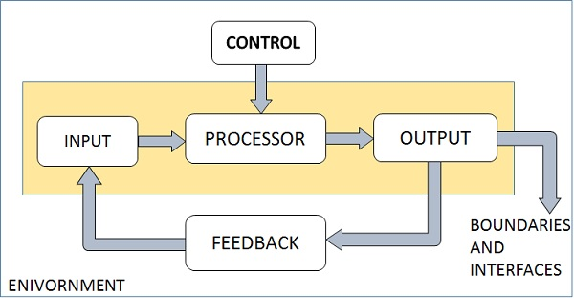

Figure 4.1: Elements of a system

Outputs and Inputs-

The goal of a system is to create an output that is useful to its user. Inputs are the data that are sent to the system for processing. The output is the outcome of the process.

Processor(s)-

The processor is an integral part of a system, and it involves converting input into output. It can modify the input as the output specification changes. In some cases, the processor can also perform other tasks related to the transformation.

Control-

The control element of a computer system is a central component that determines the actions that are performed in the system. It is also responsible for controlling the system's behavior. The activities of the computer are controlled by the software and the operating system. In order to maintain a balanced system, the output specifications are determined.

Feedback-

Feedback is a process that provides the control over a dynamic system. It is a routine part of the system's development that encourages the performance. On the other hand, negative feedback is an informational tool that informs the system's controllers about the actions that are required.

Environment-

The environment is also a vital part of a company's operations. It determines the way a system should function. For example, if a competitor or vendor influences the system's performance, the environment might give them with constraints that could affect the company's performance. The environment can also provide a vendor or competitor with constraints that could affect the way a system should function.

Boundaries and Interface-

The boundaries of a system are the limits that define its various components and processes. They are also the factors that influence and control its behavior when it interfaces with other systems. Having these boundaries helps in identifying the optimal design for a system.

**4.1.6 System Types**

The systems can be divided into the following types:

Physical or Abstract Systems-

A physical system is a collection of objects that can be touched and feel. It can be either dynamic or static. For instance, a computer is a dynamic system that can change its programs and data according to the needs of its users. Similarly, chairs and desks are the physical components of a computer center. Systems are non-physical entities that can be represented or modeled in a variety of ways.

Open or Closed Systems-

An open system is designed to interact with its environment. It can receive inputs and outputs from its environment, and it must adapt to the changes brought about by its surroundings. A closed system, on the other hand, is isolated from the environment.

Adaptive and Non Adaptive System-

An adaptive system is a system that can respond to the changes in the environment in order to improve its performance. For instance, animals and humans can adapt to the changes in the environment. However, non-adaptive systems can't respond to the environment.

Permanent or Temporary System-

The concept of a permanent system can last for a long time. For instance, a business policy can be made for a certain period of time, and then it is demolished. A DJ system can also be made for a program, and then it is dissembled after the program has ended.

Deterministic or Probabilistic System-

The concept of a deterministic system refers to the predictable interactions between various components of a system. For instance, two molecules of hydrogen can make water. However, the exact output is not known. On the other hand, a probabilistic system shows uncertain behavior.

Social, Human-Machine, Machine System-

The social system is composed of people. For instance, social clubs and societies are examples of a social system. In the Human-Machine System, both humans and machines are involved in a given task. However, in the Machine System, human interference is neglected. For instance, in programming, the machine is responsible for all the tasks.

Man–Made Information Systems-

The Direct Management Control (DMC) system is an integrated set of resources that enables organizations to manage their data. This system includes software, hardware, and communication tools. It can be used to produce reports and other related information according to the requirements of an organization.

**4.1.7 System Models**

Schematic Models-

A schematic model is a two-dimensional representation of a system's elements and their linkages. It shows information flow and material flow. The arrows represent information feedback and information flow.

Flow System Models-

A flow system model is a representation of the flow of energy, material, and information within a system. It can be used to evaluate the system's overall structure and perform review procedures.

Static System Models-

The relationships between various factors such as cost-quantity or activity-time are shown in the Gantt chart. For instance, the chart shows a static picture of the relationship between cost-quantity and activity-time.

Dynamic System Models-

Dynamic systems are business organizations that are designed to operate differently from one another. This model shows how different applications and organizations are handled by analysts.

Categories of Information-

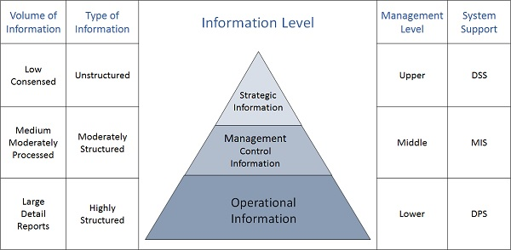

Figure 4.2: Flowchart for different categories of information

Strategic Information-

This is the information that top management needs to make informed decisions regarding their long-range planning. This includes trends in various areas such as financial investment, human resources, and revenues. With the help of a Decision Support System, this type of information can be easily accessed and analyzed.

Managerial Information-

Middle management often require a variety of information regarding a short and long-range planning process. This type of information is usually gathered through a MIS or management information system , such as a cash flow projection.

Operational information-

This is a type of information that is required by low management to enforce daily tasks and activities. It can be used to keep track of employee attendance and purchase orders. With the help of data processing systems, it can be performed efficiently.

## Overview of System Design

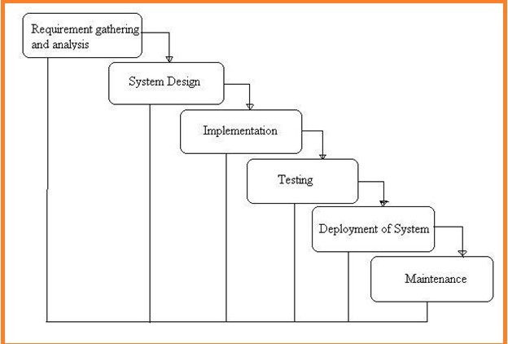

Figure 4.3: Overview of System Design

The above Figure 4.1 shows the overview of system design, central to which the ‘SOCIAL Q&A’ has been made. Here, Windows is the platform which is connected to the backend server and database.

## Methodology

The methodology employed for this project is demonstrated in the following figures:

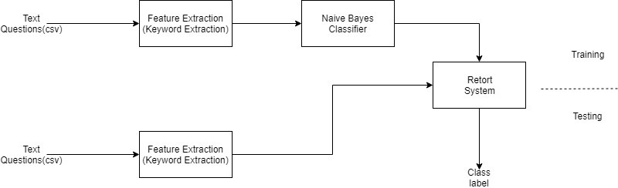

Figure 4.4: Methodology

## UML Diagram

### Class Diagram

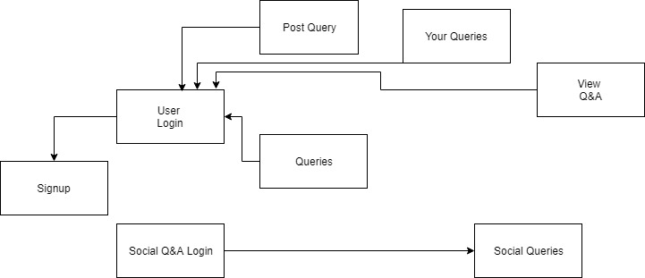

Figure 4.5: Class Diagram

### Use Case Diagram

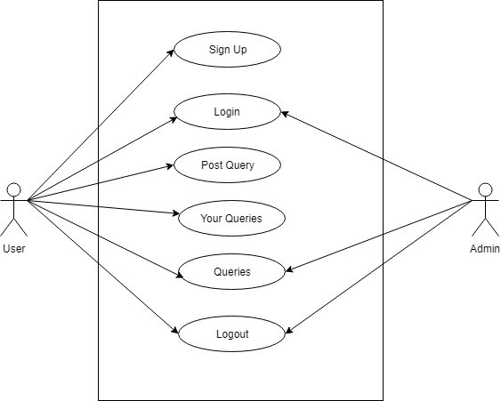

Figure 4.6: Use Case Diagram

### Data Flow Diagram

Figure 4.7: User Data Flow Diagram

### Sequence Diagram

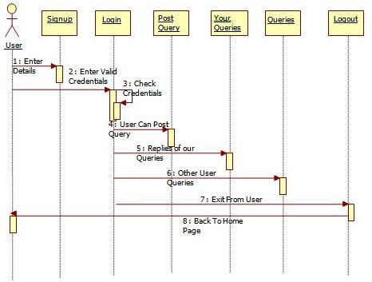

Figure 4.8: User Sequence Diagram



Figure 4.9: Admin Sequence Diagram

### Component Diagram

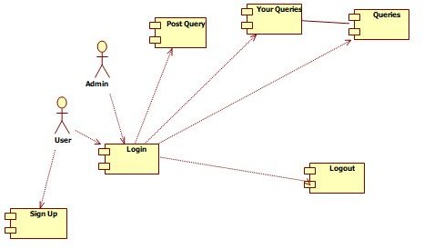

Figure 4.10: Component Diagram

# 

# Chapter 5

# Implementation

The process of accomplishing a plan or methodology is often referred to as the implementation procedure. It involves transforming the plans and methodologies into actions that will fulfill the goals and objectives of the project.

## Modules

### User Module:

Client can login as register qualifications. After login as client can look companions, send as companion solicitation and discover the companions who send the companion demand. Client can post the inquiries, see the answers of on posted questions and answer the some other companion inquiries.

### Admin Module:

The Admin recognizes the inquiries classification and add the inquiry to the class. He/She can see all answers of questions. After then send inquiries to related intrigue clients to address that question. Ascertain the appropriate responses according to calculation and appoint the qualities.

## Algorithm used in Project

In AI, we are constantly looking for the best hypothesis (*h*) presented to us. For instance, if we have a hypothesis that is good for one particular type of information, then we might choose that hypothesis as the class to relegate to another type of information (.

One of the most common methods of choosing the best hypothesis is by looking through the information that we have available. The Bayes' Theorem allows us to estimate the probability of a hypothesis being presented to us.

Bayes' Theorem is expressed as:

P(|d) = (P(*d* |*h*) * P(*h*)/P(*d*)

Where

* P(*h*|*d*) is the probability of hypothesis *h* given the information *d*. This is known as the back probability.
* P(*d* |*h*) is the probability of information d given that the hypothesis h was valid.
* P(*h*) is the probability of hypothesis h being valid (paying little mind to the information). This is known as the prior probability of h.
* P(*d*) is the probability of the information (paying little mind to the hypothesis).

We are trying to determine the probability of P(*h*|*d*) with respect to the previous probability of P(*h*) obtained from P(*d*) and P(*d|h*).

After having determined the back probability of various theories, one can then choose the most extreme one. This is regarded as the greatest posteriori (MAP) hypothesis.

This can be composed as:

MAP(*h*) = max(P(*h*|*d*))

or on the other hand

­

MAP(*h*) = max((P(*d*|*h*) * P(*h*))/P(*d*))

or on the other hand

MAP(h) = max(P(d|h) * P(h))

The P(*d*) is a normalized term that allows us to estimate the probability of a given outcome. It can be dropped when we are interested in the most plausible hypothesis.

In a situation where there are many cases in each class, the probability of each class being equal is called characterization. This is a steady term that can be dropped once more. For instance, if there are many cases in each class, the probability of each class being equal would be equivalent.

MAP(*h*) = max(P(*d* |*h*))

The Naive Bayes system is a straightforward method to calculate an order for multi-class and double classes characterization issues. It's also very straightforward to comprehend when utilizing all out info esteems.

A numbskull Bayes or naive Bayes is a type of hypothesis that is characterized by the fact that the estimation of probabilities is streamlined to make it easier to figure out. As opposed to trying to estimate the various characteristic esteems P(,, |*h*) of a given hypothesis, these are regarded as autonomous and determined as P(|) * P(|*h*), etc.

The Naive Bayes system is exceptionally solid when it comes to estimating the order of multiple classes and double classes in genuine information. It performs well in situations where the presumption does not hold.

## Packages Used

### Scikit-Learn

In 2007, David Cournapeau and Matthieu Brucher started the Scikit-learn project, which was initially created as a Google summer of code venture. In 2010, the project was included in the INRIA project. The primary open discharge of the project was released in January 2010. The project has been sponsored by various organizations, such as Google, the Python Software Foundation, and INRIA.

Scikit-learn is a library that allows people to perform unsupervised learning calculations in Python. It is based on the SciPy (Scientific Python) framework and is available under a variety of Linux distributions. Before you can use the library, you must first introduce the SciPy to the users. This stack incorporates:

* **SciPy**: Fundamental library for scientific computing
* **IPython**: Enhanced interactive console
* **Matplotlib**: Comprehensive 2D/3D plotting
* **Sympy**: Symbolic mathematics
* **Pandas**: Data structures and analysis
* **NumPy**: Base n-dimensional array package

The modules for SciPy known as SciKits are typically referred to as augmentations or modules. These give learning calculations and are named scikit-learn. The vision of the library is to provide a powerful and comprehensive framework for the use of emerging frameworks. This concept is focused on the quality of work and documentation, as well as the execution of projects. Despite the interface being Python, c-libraries are still very important for execution. For instance, numpy is used for network activities and exhibits, while LAPACK and LibSVM are useful for handling complex tasks.

### Flask

The flask web system is a set of tools and innovations that allow people to create web applications. These include web pages, blog posts, and interactive applications. You can also use these tools to create various websites and applications such as an online timetable Flask is a micro web framework written in Python. It is classified as a micro framework because it does not require particular tools or libraries. It has no database abstraction layer, form validation, or any other components where pre-existing third-party libraries provide common functions. However, Flask supports extensions that can add application features as if they were implemented in Flask itself. Extensions exist for object-relational mappers, form validation, upload handling, various open authentication technologies and several common framework related tools.Applications that use the Flask framework include Pinterest and LinkedIn. The Flask framework is a part of a small scale system that's typically light. This type of structure doesn't have any outside conditions, which makes it ideal for people who want to work with minimal resources. However, it can be very challenging to maintain, as it requires a lot of work to maintain and update. The Pros of this system are that it doesn't require a ton of work to maintain, but its time consuming to add new modules.

* Werkzeug a WSGI utility library
* jinja2 which is its format motor

An application model is a representation of a theoretical or genuine item that's used in the development of a particular application. For instance, in a case of a vehicle vendor, you might describe a car model that embodies the majority of the vehicle's characteristics and conduct.

In this situation, you're creating a To-Do List with multiple tasks that have a place for each user. Before you start thinking about how these objects are identified with one another, it's important to first define objects for both the Users and Tasks. The SQL Alchemy bundle is designed to introduce the database structure to the users.

In this tutorial, you'll describe a model that will reside in the database, and you'll also describe its characteristics. Each segment of the tutorial will also introduce a different information type, which will be used to call the database's column.

The model definition should be separated from the app.py framework's application setup. This makes sense since the model consumes a lot of theoretical space. The Task model should also have the necessary properties:

* id: an esteem that is a novel identifier to pull from the database
* name: the name or title of the assignment that the client will see when the undertaking is recorded
* note: any additional remarks that an individual should need to leave with their errand
* creation_date: the date and time the undertaking was made
* due_date: the date and time the undertaking is expected to be finished (if by any stretch of the imagination)
* completed: an approach to show whether the undertaking has been finished

# Chapter 6

# System Testing

## Introduction

A testing process is carried out to identify errors in a working product. It can also look into the various sub-components and components of the finished product. The goal of testing is to make sure that the software system is working properly and that it does not cause issues. This process is carried out through the use of live data and test data. System testing is a type of software that is performed on a complete system to evaluate its compliance with the requirements of the program. In this process, the various components of the system are tested to ensure that they are working properly.System testing is carried out to identify defects in the various components of the system. It also tests the behavior of the system when it is being tested. This process is carried out in the context of either the functional or system requirements specifications.The goal of system testing is to evaluate the design and behavior of the software as well as the expectations of the customers. It is carried out to ensure that the system is working properly. This process is carried out by an independent testing team that is not part of the development team.Non-functional and functional testing is also conducted on the system. This process is performed before the acceptance testing and after the integration testing.

## Types of tests

### Unit Testing

This process is used to test various aspects of a company's operations and systems. It ensures that the procedures and inputs are documented properly.

A test process is usually performed in phases. The first step involves creating a set of test cases that test the program's internal logic. These cases should also check the validity of the inputs. After the case has been established, the other steps are then performed to check the various decision branches and internal code flows. This method is an invasive technique that relies on the knowledge of the program's construction.

The testing process is often conducted as part of a larger unit and code test phase, which is often conducted separately. This ensures that the various parts of a company's software are thoroughly tested.

The testing process is a critical component of the software life cycle, as it is often conducted as part of a combined code and unit test phase. It is not uncommon for both the coding and unit testing phases to be conducted separately.

### Strategy and approach

The process of testing is one which is carried out manually and all the functional tests are written down in detail.

### Objectives

* + - 1. The field entries used in the process must work properly.
      2. Pages associated with an identified link related with the process must be activated.
      3. The entry screen, messages and responses to the process must not be delayed.

### Cases to be tested

1. All the entries must be verified so that they are in the correct format.
2. Duplicate entries should not be allowed.
3. It should always lead the user to the correct page.

### Unit test considerations

The goal of this process is to ensure that the information flows properly from the module to the unit. In addition to checking the interface, the other steps are also regularly examined to maintain the integrity of the program.

The conditions are tested to ensure that a module can operate within a boundary bounded. The control structures that allow a module to run are restricted to ensure that all statements are executed at the same time. Finally, the one-handling paths are checked.

### Unit test procedures

Testing is one of the procedures that is carried out during coding. Initially the source level code is tested, it reviewed by programmers and verified for correct syntax, it’s after this process that unit test case design begins and a stand-alone program/driver is developed for each test case. The main role of the driver is that it accepts test case data, which is tested with each module and finally prints the relevant results. Tests are also performed to replace the modules that are currently being tested. A subprogram is created that takes advantage of the interface of a subordinate module and then returns an entry for each verification. The drivers and scrubs are overhead software that are not delivered with the final product. The drivers and stubs are also kept low in order to reduce the overhead. The unit test procedure performed successfully. The data flows evenly across the various parts of the project.

### Integration testing

A standard integration test is conducted to check if a certain component of a program can be integrated into a standalone program. It's mainly focused on the basic details of the program's operations. Although the tests are usually performed to ensure that the various components are working properly, they can also show that the combination works correctly.

An integration test is a process that involves testing two or more software components on a single platform to identify the defects caused by interface defects. This step is usually performed to check if the various components of the system interact with errors.

**Results:** All the test cases mentioned above passed successfully. No defect encountered.

The process of software testing involves grouping together various modules and testing their reliability and functional requirements. This is done to verify the correctness of the design specifications. The design items that are being tested are accessed through a black box.The data inputs and parameters used during the process are used to simulate the various errors and success cases that can be encountered during the software testing process. In order to ensure that the various components interact properly, the test cases are prepared. This step is carried out after testing individual modules.

The concept of a building block approach is to create a database that holds all the verified assemblages that are required to perform integration testing. This process is carried out in order to form a major part of the system. Each component of the system is then combined to form a single part of the integration testing process. In addition to creating a functional program structure, integration testing also involves identifying errors in the design. This process is carried out in order to build a replica of the design. The goal of unit testing is to use the various modules that are tested to create a replica of the design.

### Top-down Integration

The incremental approach is a method that involves moving down the structure of a program. It involves testing the various components of the program on a single platform. The goal of software integration testing is to identify and fix interface defects.

The process of integration testing for Server Synchronization involves testing the various components of the program. The first step is to establish the IP address of the application. This is done to ensure that the communication between the nodes is secure. The route status of the cache table is also checked after each node receives the status information.

### Testing Objectives

The goals of testing include the following:

1. A test is a process that involves testing a program with the goal of finding an error.
2. Generally speaking, a good test case is one where the probability of finding an error is high.
3. A successful test is one where the program successfully uncovers an error.

In order to uncover errors it is mostly recommended to conduct testing in accordance to the above mentioned objectives. It also ensures that each software function works according to the specification whose conditions are met by performance requirements.

## Functional testing

A functional test is a process that aims to demonstrate the capabilities of a specific function. It is usually performed to provide a demonstration of the available features and technical requirements of the system.

Functional testing is centered on the following items:

Valid Input : All classes which have valid input must be accepted. Invalid Input : All classes having invalid input must be rejected.

Functions : All the identified functions must be exercised.

Output : All the identified classes of the application output must be exercised.

Systems/Procedures : All parts of the procedures and interfacing systems must be invoked.

## System testing

System testing is a process that involves testing the requirements of an integrated system. This process is usually performed in a configuration-oriented manner. It ensures that the results of the test are predictable. Another common type of system testing is the integration point test. This process description emphasizes the importance of having a defined set of workflows and integration points.

System testing is a process that involves analyzing the various components of a system, regardless of its type of hardware or software. This type of testing is similar to black box testing, except it does not require knowledge of the inner workings of the software. It is also conducted to check if there are inconsistencies between the various components. System testing is a type of testing that focuses on identifying defects in a system. This type of testing can also help identify issues that are related to the inter-assemblage.

A system testing process is usually carried out to identify and improve the functionality of a system. It usually happens before or after it has been integrated. The tests are carried out in order to identify and fix issues before they can affect the end users. These procedures help identify the common mistakes that can affect a system's performance. Usually, a tester tries to break a system by entering its data in a way that could cause it to malfunction. For instance, if they want to check the response to an input by entering a city in a search engine, they might use methods that only accept states. A system testing process is carried out to analyze the design and behavior of a computer system. It usually involves gathering information about the system's functional requirements and its expected behavior.

System testing is a process that involves analyzing the design and behavior of a system. It is carried out in the context of a functional requirement specification and a system requirement specification (SRS). This type of testing also checks the expected behavior of the system. **Tools used for System Testing :**

1. JMeter
2. Gallen Framework
3. Selenium

**Advantages of System Testing :**

* The testers do not require more knowledge of programming to carry out this testing.
* It will test the entire product or software so that we will easily detect the errors or defects which cannot be identified during the unit testing and integration testing.
* The testing environment is similar to that of the real time production or business environment.
* It checks the entire functionality of the system with different test scripts and also it covers the technical and business requirements of clients.
* After this testing, the product will almost cover all the possible bugs or errors and hence the development team will confidently go ahead with acceptance testing.

**Disadvantages of System Testing :**

* This testing is time consuming process than another testing techniques since it checks the entire product or software.
* The cost for the testing will be high since it covers the testing of entire software.
* It needs good debugging tool otherwise the hidden errors will not be found.

|  |  |
| --- | --- |
| **Name of the Test** | **System Testing** |
| Item being tested | Over all functioning of application with all functions properly linked. |
| Sample Input | Sample input for each of the task provided out of the box. |
| Expected Output | Students get their respected tutors |
| Actual Output | Application reacts to user inputs in expected manner. |
| Remarks | Successful |

Table 6.1: Test cases for Input-Output

### White Box Testing

This process involves having the tester complete knowledge about the software's inner workings and structure. This is usually performed in areas where the implementation of black box testing is not possible.

### Black Box Testing

The purpose of a black box test is to provide an overview of the software's inner workings and structure. It's usually done in a way that doesn't involve the knowledge of the software's language, structure, or specification. Usually, a black box test is written from a source document that describes the software's requirements and specification. This procedure is designed to provide the user with inputs and outputs without bothering with how the software works.

### Acceptance Testing

One of the most challenging phases of a project is acceptance testing. This process involves involving the end user in the process. The requirements of the system are taken very seriously and this ensures that the system is functional.

**Test Results:** All the test cases mentioned above passed successfully. No defects were encountered.

### Performance Testing

Performance testing is conducted to ensure that the output is produced within the same time limit as the system time limit. This process also ensures that the system receives the necessary response and retrieves the results.

### Experimental Results

Dataset:

|  |  |
| --- | --- |
| Class | Number of Samples |
| Films | 150 |
| Sports | 220 |
| Politics | 49 |
| Science & Technology | 98 |
| Entertainment | 300 |

Table 6.2 Samples in each class

|  |  |  |  |  |
| --- | --- | --- | --- | --- |
| Training | Classification Accuracy | Precision | Recall | F measure |
| 45% | 0.7483 | 0.6185 | 0.5302 | 0.7384 |
| 55% | 0.7623 | 0.6230 | 0.5554 | 0.7462 |
| 75% | 0.7701 | 0.6342 | 0.5415 | 0.7595 |
| 70% | 0.7764 | 0.6434 | 0.5238 | 0.7614 |
| 80% | 0.7842 | 0.6571 | 0.5765 | 0.7856 |

Table 6.3: Accuracy of ‘SOCIAL Q&A’

Five different classification tests were performed on our proposed system to check for accuracy and the results are summarized as follows:

The training: testing ratio of the dataset was 0.45: 0.55. An overall classification accuracy of 74.83% was obtained.

The training: testing ratio of the dataset was 0.55: 0.45. An overall classification accuracy of 76.23% was obtained.

The training: testing ratio of the dataset was 0.75: 0.35. An overall classification accuracy of 77.01% was obtained.

In the fourth test, the training: testing ratio of the dataset was 0.70: 0.30. An overall classification accuracy of 77.64% was obtained.

The fifth test was conducted on a larger dataset with a training: testing ratio of 0.75: 0.35 for the dataset. An overall classification accuracy of 78.42% was obtained.

## Test Cases

### Test Cases for Register Page

|  |  |  |  |  |  |  |  |
| --- | --- | --- | --- | --- | --- | --- | --- |
| **Test Case** 1 | | **Test Case Description** - Form | | | | Verification in Registration | |
| **Sl.no.** | **Pre-requirements** | | **Sl.no.** | **Testing Data Requirement** | | | |
| 1 | User should Recorded | be | 1 | Data ought to be substantial | | | |
| **Test Condition** | | | | | | | |
| Entering data in registration form | | | | | | | |
| **Act no.** | **Act Details** | **Expected Results** | | | **Actual Results** | | **Pass/Fail/Not Executed/Suspended** |
| 1 | User enters First and Last Name | Popup indicating email confirmation message | | | Enter valid email/password | | Failure |
| 2 | Submitting the form without entering any details | Popup indicating email confirmation message | | | Enter  /password | email | Failure |
| 3 | User enters invalid format of email id | Popup indicating email confirmation message | | | Enter valid email id | | Failure |

|  |  |  |  |  |
| --- | --- | --- | --- | --- |
| 4 | User enters a phone number with < 10 digits | Popup indicating email confirmation message | Enter valid phone number | Failure |
| 5 | Entering valid username and password | Popup indicating email confirmation message | Pop showing email verification message | Passed |

Table 6.4: Registration test case

### Test Cases for Login Page

|  |  |  |  |  |  |
| --- | --- | --- | --- | --- | --- |
| **Test Case** 2 | | **Test Case Description** - Verification in Login Form | | | |
| **Sl.no.** | **Pre-requirements** | | **Sl.no.** | **Test Data Requirement** | |
| 1 | User should have an email id | | 1 | Data ought to be substantial | |
| **Test Condition** | | | | | |
| Entering data in login form | | | | | |
| **Step no.** | **Step Details** | **Expected Results** | | **Actual Results** | **Pass/Fail/Not Executed/Suspended** |
| 1 | User gives a email or  password of  less than 6 characters | User has been logged in | | Enter valid email/password | Failure |
| 2 | Submitting the form without entering any details | User has been logged in | | Enter email  /password | Failure |
| 3 | User enters  wrong Email and (or)  password | User has been logged in | | Enter valid email  /password | Failure |

Table 6.5: Login test case

# Chapter 7

# Results and Discussion

In Figure 7.1, the login dashboard can be seen for SOCIAL Q&A.

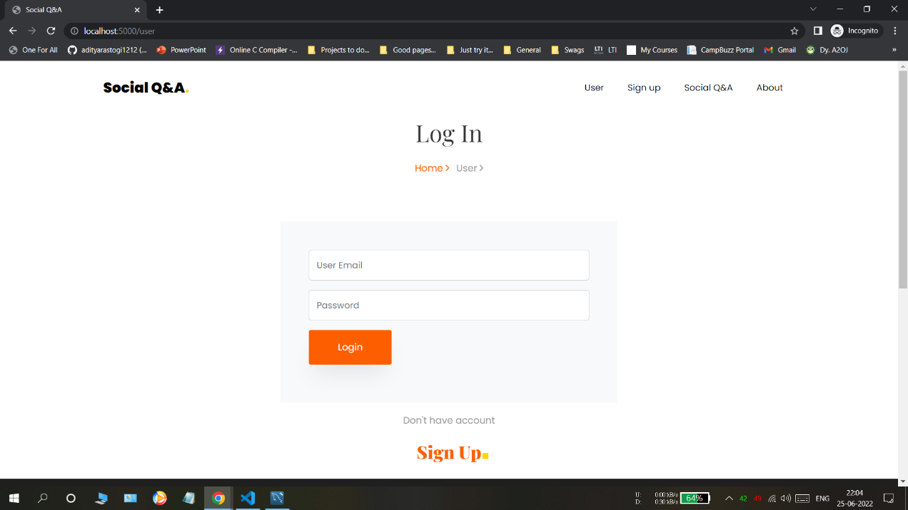

Figure 7.1: Login Page

In Figure 7.2, the admin login can be seen for SOCIAL Q&A

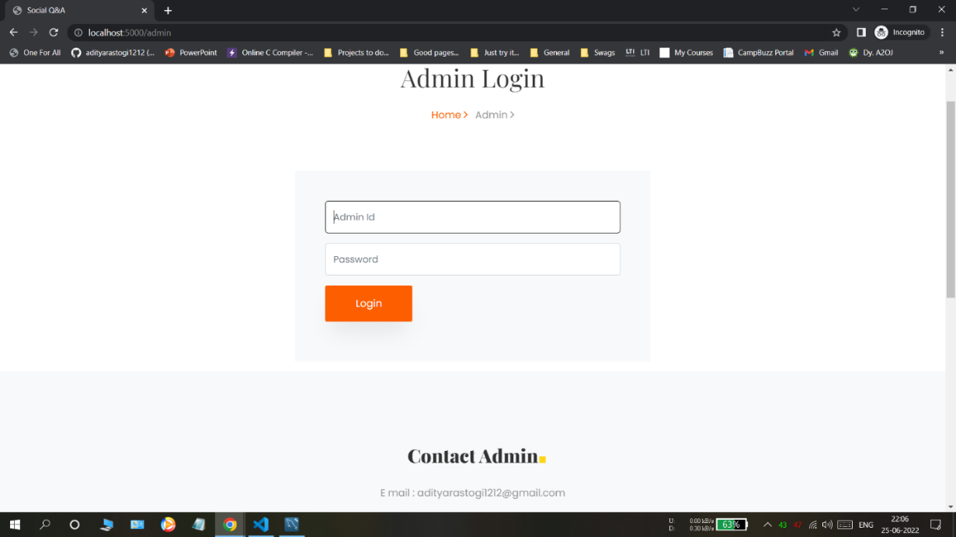

Figure 7.2: Admin Login

In figure 7.3, the signup menu for the new user can be seen, where various data like first name, last name, address, city etc. is collected from the user for successful signup.

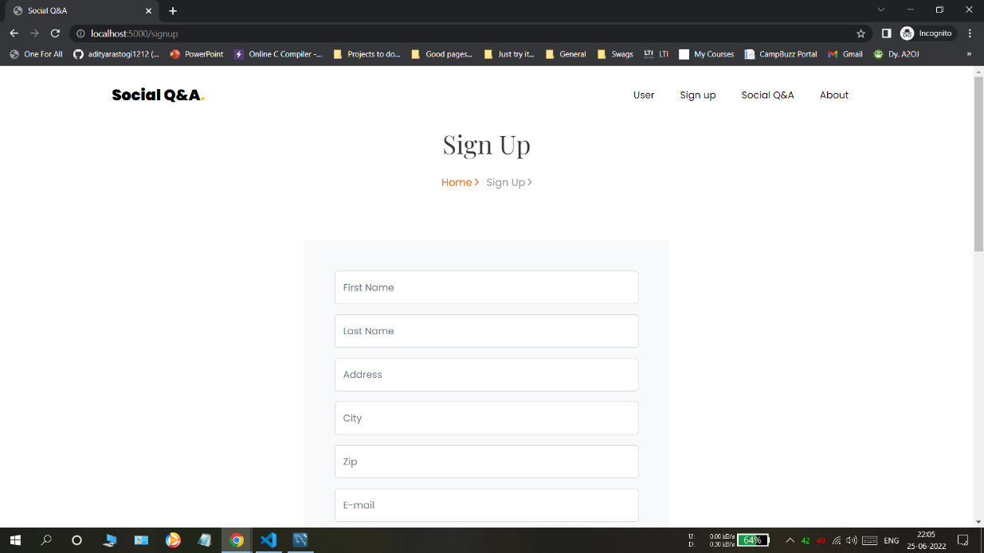

Figure 7.3: User Signup

In Figure 7.4, the login dashboard can be seen of the user. Here, the user has various options like post query, answer other queries or look at their own queries asked.

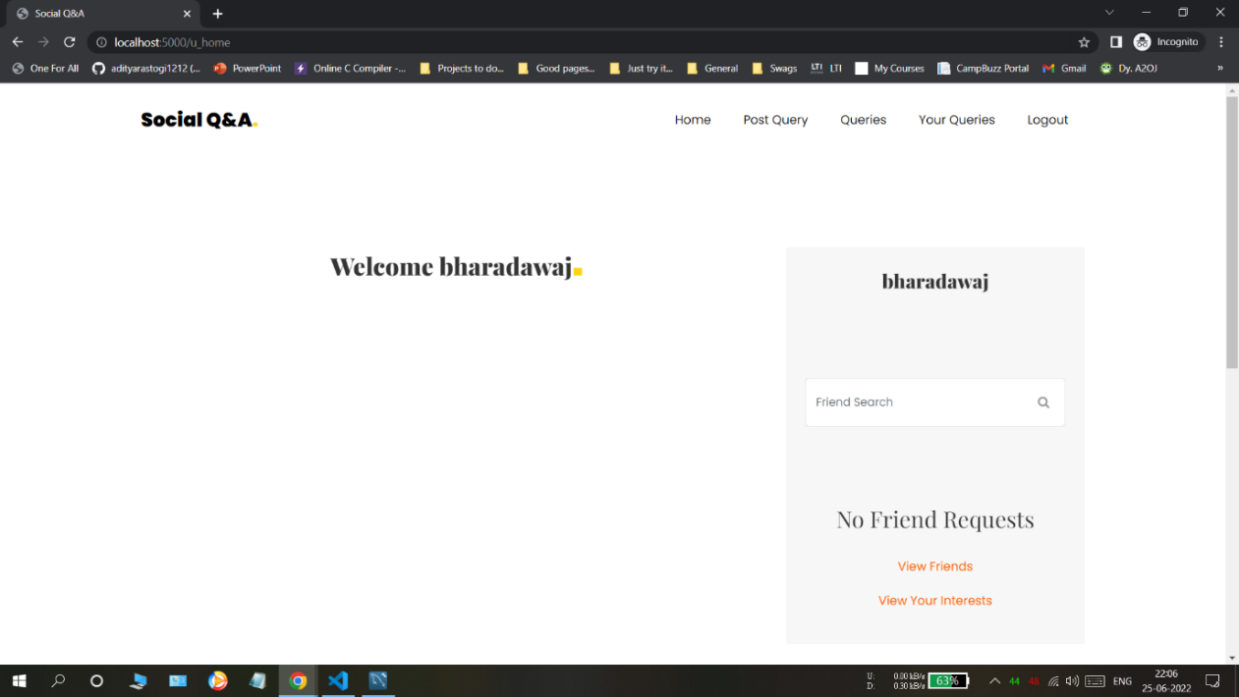

Figure 7.4: User dashboard

In Figure 7.5, we can see the user dashboard for posting a new query.

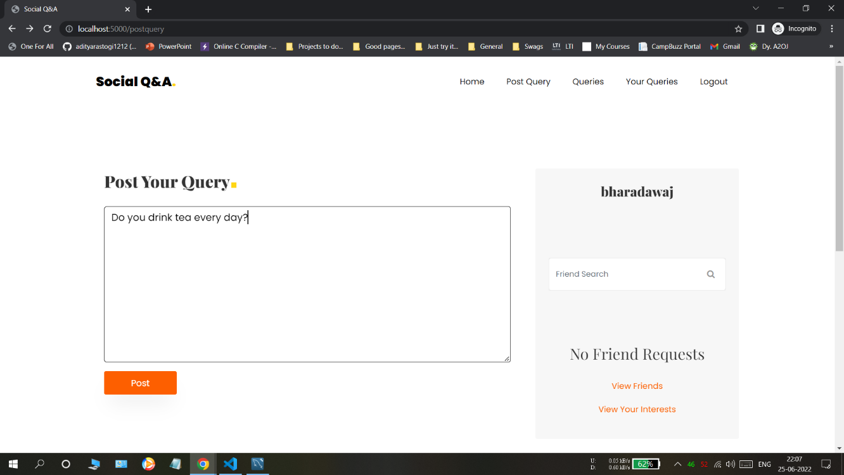

Figure 7.5: Post Query

In Figure 7.6, we can see the queries asked by other users.

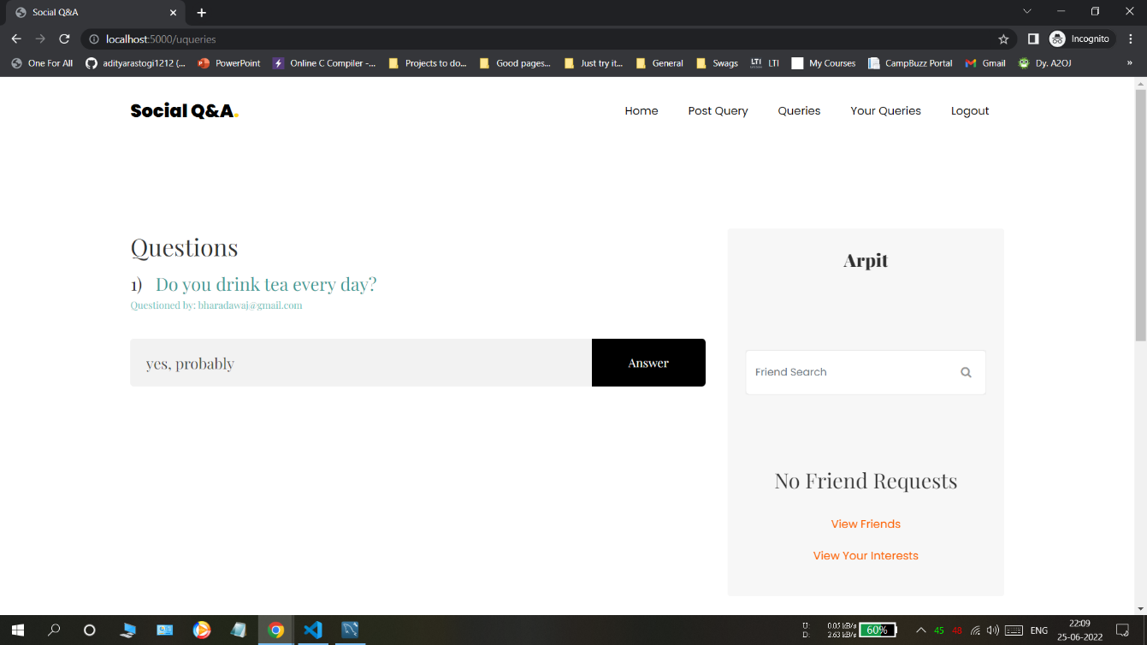

Figure 7.6: Other User Queries

In Figure 7.7, we can see our previous queries and their answers, which have been given by the user’s friends.

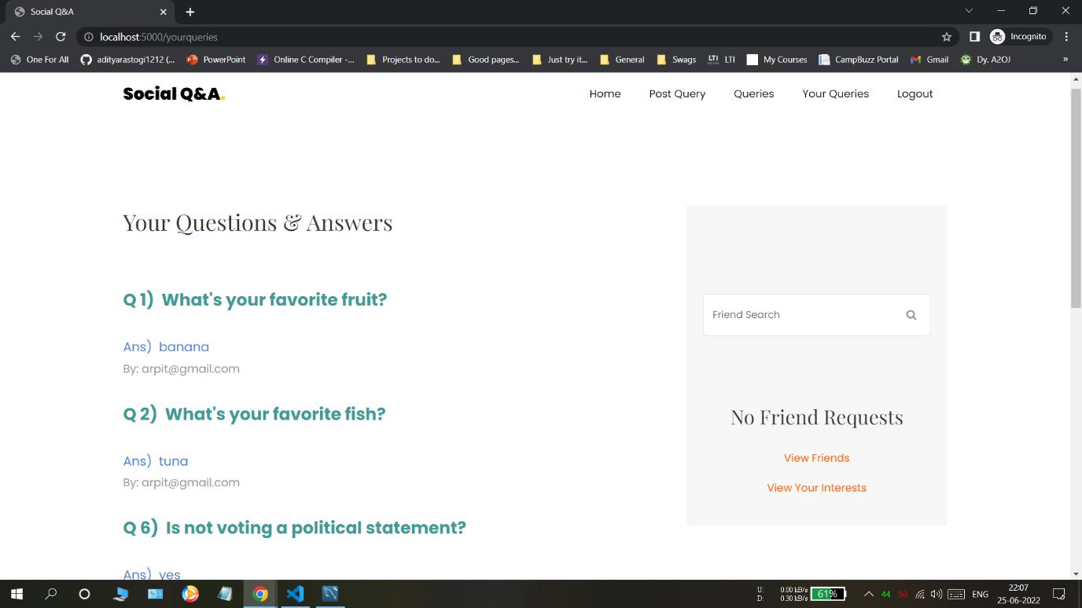

Figure 7.7: User Queries

In Figure 7.8, we can see the admin dashboard after the admin has logged in

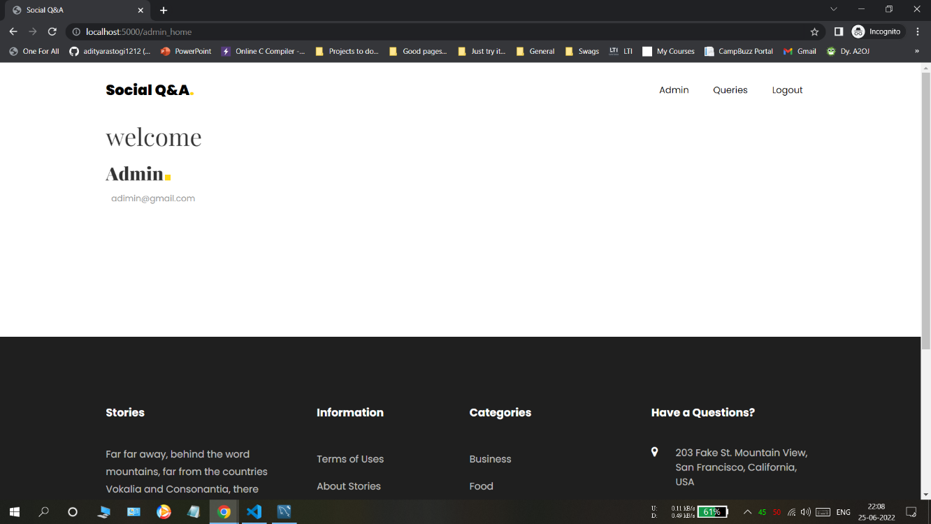

Figure 7.8: Admin Dashboard

In Figure 7.9, the admin processes each query, where we find the category of the question and it also decides to which friend the question is forwarded.

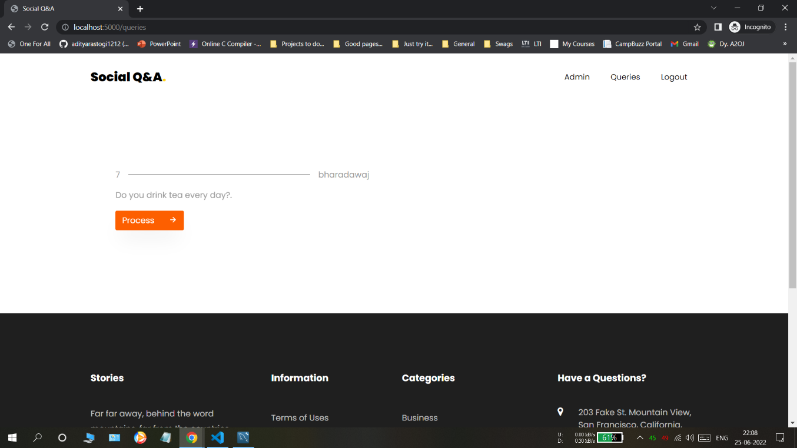

Figure 7.9: Admin Category

# Chapter 8

# Conclusion and Future Scope

## Conclusion

Our platform, called Social Q&A, allows users to post their own questions and answers and view the results of their queries that have been forwarded to them by other users. They can also see the other questions that they have previously asked and their answers.

## Future Scope

In the future, Social Q&A will be enhanced with a wide variety of class labels, which will allow it to provide even greater accuracy and allow users to create their own applications. This feature can be easily implemented with an Android app. The query forwarding process can be automated, which will allow it to classify the questions and send them to other users without requiring the admin. It can also be modified to answer them by itself.

Through the use of various techniques, such as topic modelling and word embedding, users can easily find the answers to their questions.

# References

1. Haiying Shen , Guoxin Liu , Haoyu Wang , Nikhil Vithlani. SocialQ&A: An Online Social Network Based Question and Answer System, 2017

[2] G. Drosatos, P. Efraimidis, A. Arampatzis, G. Stamatelatos, and I. Athanasiadis. Pythia: Privacy-enhanced Personalized Contextual Suggestion System for Tourism, 2015.

1. Sabrina Gaito, Elena Pagani ,Gian Paolo Rossi. Contact Analysis in Workplace, 2009 .
2. Matthew Richardson and Ryen W. White. Effects of expertise differences in synchronous social Q&A ,2012 .
3. M. R. Morris, J. Teevan, and K. Panovich. A Comparison of Information Seeking Using Search Engines and Social Networks. In In Proc. of ICWSM, 2010.
4. L. A. Adamic, J. Zhang, E. Bakshy, and M. S. Ackerman. Knowledge Sharing and Yahoo Answers: Everyone Knows Something. In Proc. of WWW, 2008.
5. A. Spagnolli and L. Gamberini. Interacting via sms: Practices of social closeness and reciprocation. British Journal of Social Psychology, 2007.
6. Ze Li, Haiying Shen Jin Li, Guoxin Liu. SOS: A Distributed Mobile Q&A System Based on Social Networks , 2013 .
7. B. Li, I. King, and M. R. Lyu. Question Routing in Community Question Answering: Putting Category in its Place. In Proc. Of CIKM, 2011.
8. L. Nie, Y. Zhao, X. Wang, J. Shen, and T. Chua. Learning to recommend descriptive tags for questions in social forums. TOIS, 2014.
9. N. A. Christakis and J. H. Fowler. Connected: The surprising power of our social networks and how they shape our lives. Hachette Digital, 2009.
10. A. Shtok, G. Dror, Y. Maarek, and I. Szpektor. Learning from the past: Answering new questions with past answers. In Proc. of WWW, 2012.